**RAJDEEP DAS**

**EMP ID: 2152683**

**COHORT: OSP002**

**1ST JUNE (2022) ASSIGNMENT ORACLE EBS**

**-- Q1. Query to list all the responsibilities assigned to the user**

SELECT DISTINCT RESPONSIBILITY_NAME

FROM FND_RESPONSIBILITY_TL FRT, FND_USER_RESP_GROUPS_DIRECT FURGD, FND_USER FU

WHERE FRT.RESPONSIBILITY_ID = FURGD.RESPONSIBILITY_ID

AND FURGD.USER_ID = FU.USER_ID

AND FU.USER_NAME = 'XXCTS_RAJDEEP';

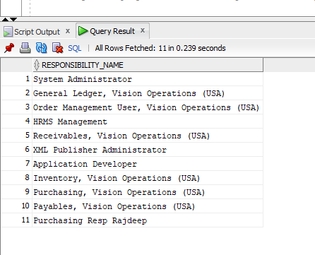

**--Q2. Query to display the Menu Name assigned to the newly created responsibility**

SELECT MENU_NAME

FROM FND_MENUS FM, FND_RESPONSIBILITY FR

WHERE FM.MENU_ID=FR.MENU_ID

AND FR.CREATION_DATE= (SELECT MAX(CREATION_DATE)FROM FND_RESPONSIBILITY)

ORDER BY MENU_NAME;

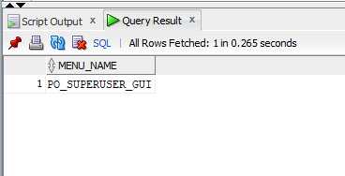

**-- Q3. Query to display whether the user is a Person, Employee or Supplier**

DECLARE

X_EMPLOYEE FND_USER.EMPLOYEE_ID%TYPE;

X_CUSTOMER FND_USER.CUSTOMER_ID%TYPE;

X_SUPPLIER FND_USER.SUPPLIER_ID%TYPE;

BEGIN

SELECT EMPLOYEE_ID, CUSTOMER_ID, SUPPLIER_ID INTO X_EMPLOYEE, X_CUSTOMER, X_SUPPLIER FROM FND_USER

WHERE USER_NAME='XXCTS_RAJDEEP';

IF X_EMPLOYEE != NULL THEN

DBMS_OUTPUT.PUT_LINE('THIS USER IS EMPLOYEE');

ELSIF X_CUSTOMER != NULL THEN

DBMS_OUTPUT.PUT_LINE('THIS USER IS CUSTOMER');

ELSE

DBMS_OUTPUT.PUT_LINE('THIS USER IS SUPPLIER');

END IF;

END;

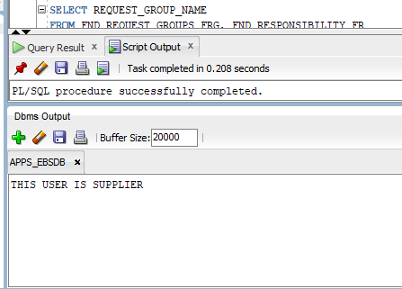

**--Q4. List of all Responsibilities**

SELECT DISTINCT RESPONSIBILITY_ID, RESPONSIBILITY_NAME FROM FND_RESPONSIBILITY_TL;

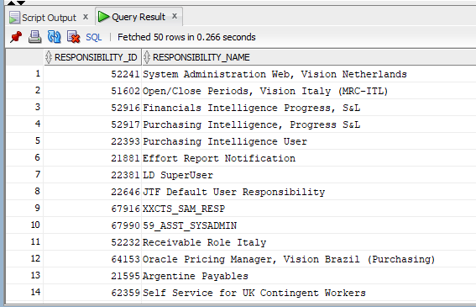

**--Q5. Query to display the request group name**

SELECT DISTINCT REQUEST_GROUP_NAME FROM FND_REQUEST_GROUPS;

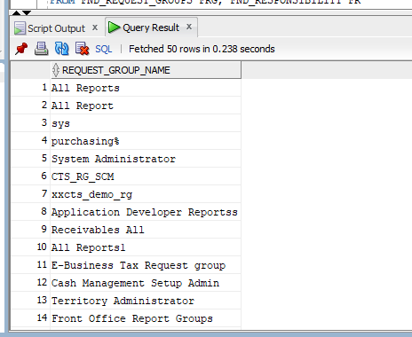

**--Q6. Query to display the request group name for a specific responsibility.**

SELECT REQUEST_GROUP_NAME

FROM FND_REQUEST_GROUPS FRG, FND_RESPONSIBILITY FR

WHERE FRG.REQUEST_GROUP_ID=FR.REQUEST_GROUP_ID

AND FR.RESPONSIBILITY_KEY='XXCTS_RAJDEEP_RESP_MAY22';

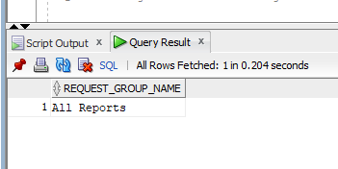

**--Q7.Query to display the Application name for a Specific Responsibility**

SELECT DISTINCT APPLICATION_NAME

FROM FND_APPLICATION_TL FAT, FND_RESPONSIBILITY FR

WHERE FAT.APPLICATION_ID=FR.APPLICATION_ID

AND FR.RESPONSIBILITY_KEY='XXCTS_RAJDEEP_RESP_MAY22';

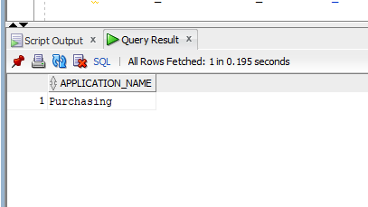

**--Q8. Can we join two tables using WHO Columns?**

-YES WE CAN JOIN

**--Q9. Display all the details of a specific USER.**

SELECT * FROM FND_USER WHERE USER_NAME='XXCTS_RAJDEEP';

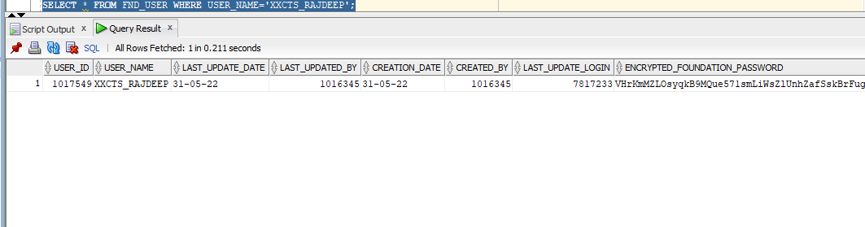

**--Q10. Display all the details of a specific Responsibility.**

SELECT * FROM FND_RESPONSIBILITY

WHERE RESPONSIBILITY_KEY='XXCTS_RAJDEEP_RESP_MAY22';

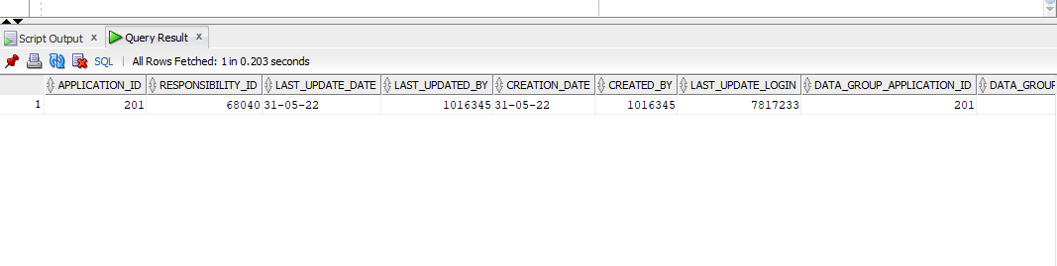

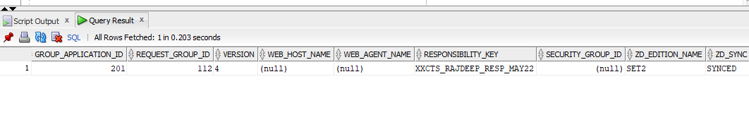

**THE END**